7th/8th Homeroom 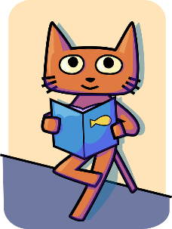
Language Arts/History/Art
Mrs. Meyer
kristinmeyer@trinitylutheranalma.com

Reading. Writing. Comprehension. Communication. Learning.
These are Life Skills.

In this class we’ll be learning about history, art, and English. We’ll work on our reading, writing, comprehension, vocabulary, speaking, listening, and language skills. You’ll work independently, in small groups, and as a whole class. We’ll use a variety of genres through various types of literature, study the history of the United States, and get creative. You’ll increase your skills to read and comprehend text across the curriculum and read and respond to a variety of information. You will write for a variety of audiences, purposes, and contexts while applying your reading and writing skills to demonstrate learning.

